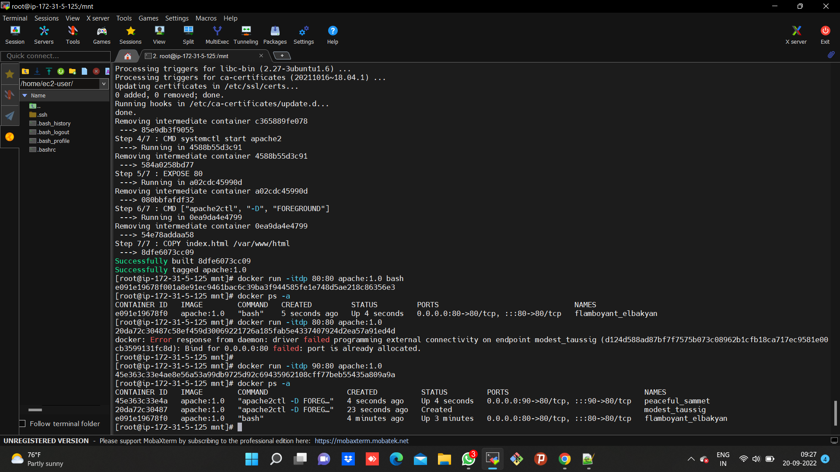

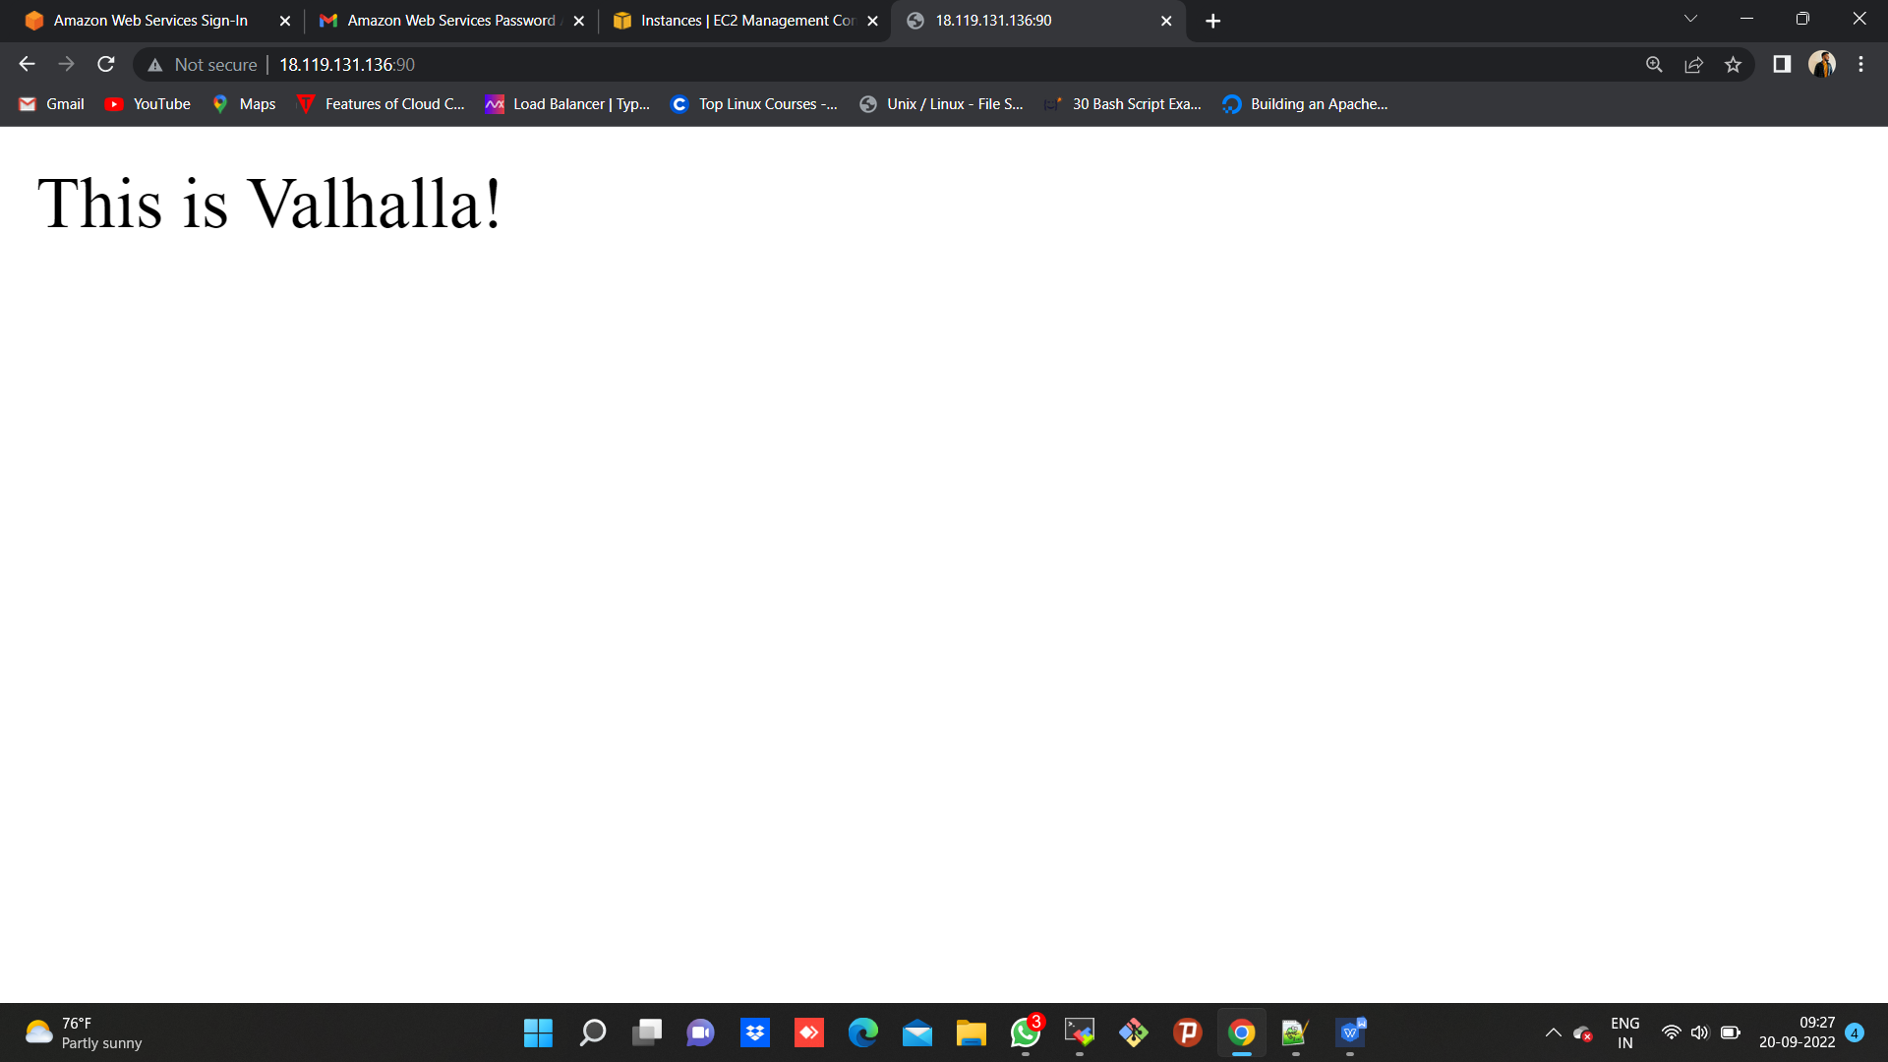

FROM ubuntu:18.04

WORKDIR /tmp

RUN apt-get update -y && apt-get install vim curl apache2 -y

CMD systemctl start apache2

EXPOSE 80

CMD ["apache2ctl", "-D", "FOREGROUND"]

COPY index.html /var/www/html

---------------------------------------------------------------------------------------------------------------------------------------

FROM ubuntu:18.04

MAINTAINER maverick

WORKDIR /roschelle

RUN apt-get update -y && apt-get install vim curl apache2 -y

EXPOSE 80

CMD ["apache2ctl", "-D", "FOREGROUND"]

COPY index.html /var/www/html